A Nature Walk
In a nature walk, a guide will take you along a specific trail they know you’ll see interesting things on. They might point them out to you, and tell you a bit about them. That what I’m going to do with you right now.
But, I don’t just want you to see the sights. I’m also showing you how an expert would conduct their exploration. They make choices about what directions to look in, and they know certain signs to look for. These are the things I want you to take away.
Without further ado…
Card Shuffling
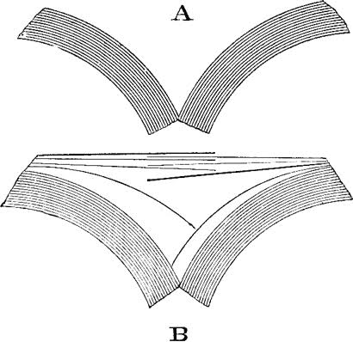
The name for a shuffle that perfectly interleves alternate cards is a farro shuffle. There are lots of tutorials on youtube instructing how you can actually do it.
Watching one of these videos, I thought that must take a lot of practice. And I wondered, if you were shuffling the same deck over and over again, would the cards ever get back in their original ordering?
This wondering is something mathematicians do a lot. They think “I wonder what would happen if…”, “I wonder if xyz is possible?”
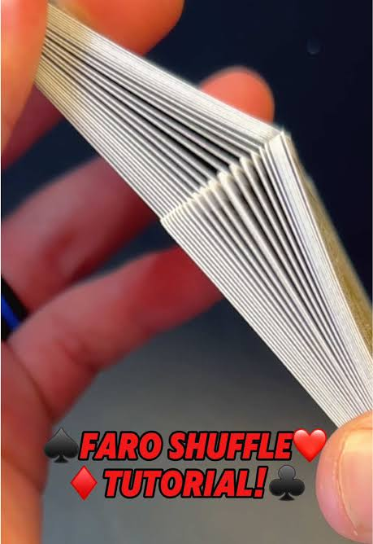
So, pause for a minute and see if you have any intuition here for random shuffling vs. farro shuffling.
- If someone is randomly re-ordering the cards with each shuffle, are the cards guarenteed to return to their original ordering after enough shuffles?

- If someone is performing a perfect farro shuffle, are the cards guarenteed to return to their original ordering after enough shuffles?
For question 1, maybe you thought, each time you shuffle there’s exactly one way of re-ordering the cards that would put them back in order. But since shuffles are random, there’s always a chance your shuffle will re-order them a different way. So shuffling as many times as you want, there’s never a 100% chance that they’d return to their original ordering.
Question 2 may not be so easy for you to think about (though there is a simple reason supporting the answer). Don’t worry if nothing occurred to you! Let’s tinker around a bit more and maybe something will.

Two Problem Solving Nudges
Let’s investigate the question of how many (perfect farro) shuffles does it take to put the cards back in order?
Two good things to do when you’re stuck.
- Use a (different) representation
- Explore small examples and look for patterns
A deck of cards has 52 cards. This feels too big to easily think about, so let’s ask the same question for a smaller deck. I’ll (somewhat arbitrarily) choose a deck size of 10 cards. To make it easy to think about, let’s number the cards 1 to 10. So, if the deck starts out in order it looks like:
1 2 3 4 5 6 7 8 9 10
You can imagine the number on the left is the top card and the number on the right is the bottom card.
If someone performs a perfect farro shuffle on these 10 cards, what will they look like at the end? (There’s actually two ways they could look).
Try it!
If you want, you can see the answer at the bottom of the page

* * *
Let’s agree to use a farro shuffle where the top half of the deck goes in the left hand, and the left card is the first one put down in the shuffle.
Go ahead and try it out:
Write out what the cards look like if you do this shuffle over and over.
Write down (or show visually somehow) things you’re noticing about how the cards are moving, any patterns you see, etc.
I’ll write out what mine looks like on the next page.
Here’s the ordering of the cards after 3 shuffles.

After 0 shuffles: 1 2 3 4 5 6 7 8 9 10
After 1 shuffle: 1 6 2 7 3 8 4 9 5 10
After 2 shuffles: 1 8 6 4 2 9 7 5 3 10
After 3 shuffles: 1 9 8 7 6 5 4 3 2 10

There are lots of things to notice here. Here are a few…
- The 1 and the 10 are always in the same spot.
- After one shuffle you see the initial cards get spaced out like this:
1 __ 2 __ 3 __ 4 __ …
- The 4 and the 7 trade locations every shuffle
- After 3 shuffles, the cards are in reverse order (except for 1 and 10).
You might realize that if 3 shuffles reversed all the inner cards, 3 more will reverse them again, so the cards will be back in order. Here’s what it looks like with all 6 shuffles:
After 0 shuffles: 1 2 3 4 5 6 7 8 9 10
After 1 shuffle: 1 6 2 7 3 8 4 9 5 10
After 2 shuffles: 1 8 6 4 2 9 7 5 3 10
After 3 shuffles: 1 9 8 7 6 5 4 3 2 10
After 4 shuffles: 1 5 9 4 8 3 7 2 6 10
After 5 shuffles: 1 3 5 7 9 2 4 6 8 10
After 6 shuffles: 1 2 3 4 5 6 7 8 9 10

Great! So with 10 cards, it takes 6 shuffles to put them back in order. But we wanted to know about 52 cards. Can we use anything here to answer our original question about 52 cards? Maybe… but it’s not exactly clear. You might want to try some more small exmaples to see what patterns there are.

Try it:
Try this process with some other deck sizes. You could go larger, like 12 cards. Or smaller like 6 or 8 cards. Write down or visually indicate things you notice about patterns or how the cards are moving.

I’ve got some results on the next page.
Here’s my results for 6 cards and 8 cards, since those feel faster to explore than larger deck sizes.
6 Cards:
After 0 shuffles: 1 2 3 4 5 6
After 1 shuffle: 1 4 2 5 3 6
After 2 shuffles: 1 5 4 3 2 6
After 3 shuffles: 1 3 5 2 4 6
After 4 shuffles: 1 2 3 4 5 6

8 Cards:
After 0 shuffles: 1 2 3 4 5 6 7 8
After 1 shuffle: 1 5 2 6 3 7 4 8
After 2 shuffles: 1 3 5 7 2 4 6 8
After 3 shuffles: 1 2 3 4 5 6 7 8

For me the big surprise was that 8 cards only took 3 shuffles! I also noticed that there is no “half-way” point where the inner cards are reversed, the way there was with 10 cards (or, you can see, with 6 cards).

You might think about organizing your results in a table. I wrote a program to simulate the process and tell me how many shuffles to get the deck back in order for lots of initial deck sizes. Here are my results:

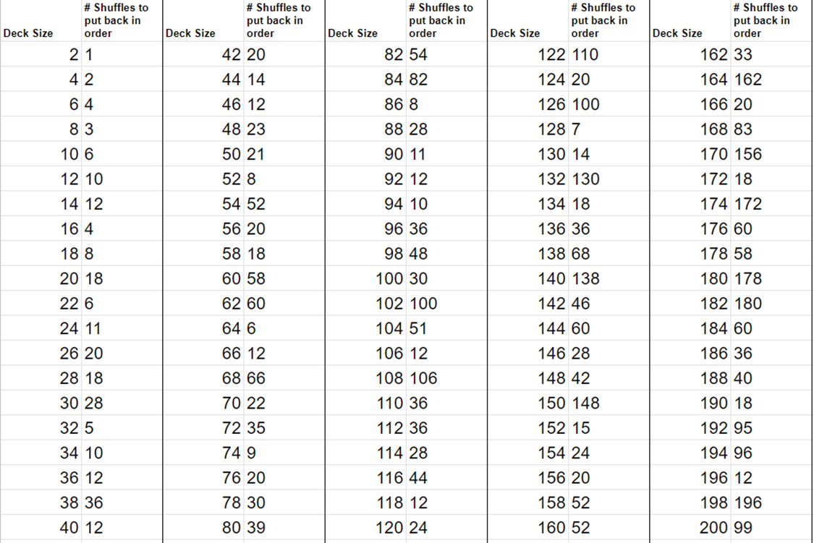

What are you noticing here?
Again, there are a lot of surprises, and a lot of specific things you might notice.

One obvious thing is that I actually answered our original question: the answer is 8. It takes 8 shuffles to get 52 cards back in order. But that answer isn’t very interesting or satisfying. I want to understand what’s going on here in general. Why does it only take 8 shuffles? Why do some deck sizes require lots of shuffles, and others only a few.

What else could we do? If we have a bunch of data, we might look at what it looks like as a graph. So here’s that same information as a graph.

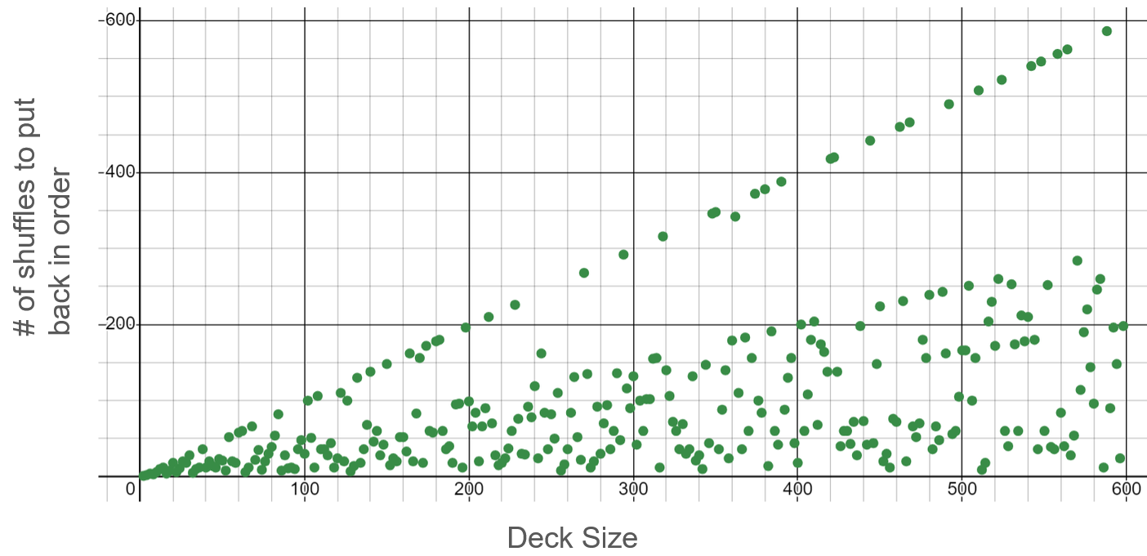

Very surprising! We see a lot of the “chaotic” shuffle numbers from the data table, but there’s a very clear line (at least, it looks like a line…?) at the “top” of all the data.

Mathematicians would call that an upper-bound. The idea is: even if we can’t say exactly how many shuffles it takes, maybe we can say that the number must be less than ____________ (something). Here, if those upper data points really make a line, we could say that it appears that the number of shuffles is always less than that line.

When doing math outside of class, it’s normal to think about a whole collection of related questions at once. Often you’re trying to understand: “what’s going on here?” in general, and there are lots of specific things you might want to explain that are related to that.

So here’s the list of questions I have now:
- Why do some deck sizes require lots of shuffles and others only a few? Why do more cards not mean more shuffles?
- Is there an equation that would let me calculate the number of shuffles based on the deck size?
- Is that upper bound really linear? If so, what’s the equation?
- Is there any way of predicting which deck sizes have very small numbers of shuffles to get back in order?
Where to go from here?

You can start trying to tackle some of these other questions if they’ve caught your interest. My advice is to pay close attention to the patterns in how individual cards move. Two other good problem-solving strategies are:

Draw a picture
Visualize the process behind the problem

So see what kinds of pictures you can draw that show the pattern of how the cards move in each shuffle. One of the pictures may make the whole pattern pop out for you.

Good luck!

Though you may also think: There’s only so many orders the deck can be in, and each time I shuffle, there’s an equal chance of ending up in each of them. So the more and more I shuffle, the bigger and bigger chance that I would have hit the original ordering. This is also true. In our probability and combinatorics unit you can look at this question more carefully.
When the deck is split in half, the farro shuffle could start with the left card first and then alternate, or the right card first and then alternate. Let’s assume the top half of the deck is in the left hand. If left card goes first, the cards will look like: 1 6 2 7 3 8 4 9 5 10. If the right card goes first, it will look like: 6 1 7 2 8 3 9 4 10 5.

